Please mark the reason you chose TLC Rehab for your physical therapy:
____ Physician referral ____ Close to home ____Family ______________________
____ Insurance Plan ____Close to work ____ Friend ______________________
____ Phone book ____ Internet _________________ ____ Other ______________________

PATIENT INFORMATION
Date: _____________ Last Name: _____________________ First Name: _____________________ M. I. ______
Birth Date: ______________ Age: ______ Name you would like us to call you: _____________________
Home phone: __________________ Cell phone: ____________________ Work phone: __________________
E-mail address: ____________________________________________________________________________________
Preferred method of contact: ____ Home ____ Cell ____ Work
Marital status: ____ Single ____ Married ____ Divorced ____Widowed ____ Other
Are you employed? ____ Yes (_________hours/week) ____ No ____ Retired
Job title/type of work: ____________________________________________________________________________
Are you disabled? ____ Yes ____ No Reason: ___________________________________________

Emergency contact: ____________________________ Relationship to patient: _______________________
Home #: _________________________ Cell #: __________________________ Work #: ______________________

HEALTH HISTORY
Have you ever had an allergic reaction to: ___ Lotion; ___ Perfume; ___ Gel; ___ Latex; ___ Adhesive ?
Other allergies: ___________________________________________________________________________________________________________

Surgeries: _________________________________________________________________________________________________________________
_____________________________________________________________________________________________________________________________

Diagnostic tests (date of test) : X-rays: (__________________) MRI: (________________) CTScan: (___________________)
Other: ___________________________________________________________________________________________________________________

Have you ever been diagnosed as having any of the following conditions?
____ Arthritis ____ Heart Problems _________________________
____ Cancer (type ______________________) ____ Circulation problems
____ High blood pressure ____ Emphysema/Bronchitis
____ Asthma ____ Thyroid problems
____ Chemical dependency (i.e. alcoholism) ____ Multiple Sclerosis
____ Diabetes ____ Fibromyalgia
____ Rheumatoid Arthritis ____ Hepatitis (Type ____________)
____ Depression ____ Stroke
____ Tuberculosis ____ Anemia
____ Kidney Disease ____ Incontinence
____ Epilepsy/Seizures ____ HIV/AIDS
____ Osteopenia/Osteoporosis ____ Other __________________________________
____ Pacemaker/Electrical implant ____ Could you currently be pregnant?
____ Hard of Hearing ____ Vision difficulties ______________________
Have you recently noted:
____ Unexplained weight loss/gain ____ Nausea/vomiting
____ Dizziness/lightheadedness ____ Fatigue
____ Weakness ____ Fever/chills/sweats
____ Numbness or tingling ____ Bowel or bladder leakage
____ Headaches ____ Other ____________________________

PATIENT’S NAME: ____________________________________________________________

Current Medications (please list):
________________________________________________________________________________________________________________________________________________________________________________________________________________________________________________________________________________________________________________________________________________________________________________________________________________________________________________________________________________________________________________________

Do you exercise beyond normal daily activities and chores? _____ Yes _____ No
How many days per week do you exercise? _____________ For how long? ___________________________________________
Describe the exercise(s): _________________________________________________________________________________________________
______________________________________________________________________________________________________________________________

Are you currently performing your normal exercise routine? _____ Yes _____ No

MEDICAL/REHABILITATIVE SERVICES

Please list any other healthcare practitioners from whom you are currently receiving services:
________________________________________________________________________________________________________________________________________________________________________________________________________________________________________________________________________________________________________________________________________________________________________________________________________________________________________________________________________________________________________________________________________________________________________________

Have you been discharged from a rehabilitation facility, skilled nursing facility, or home health recently? _____ Yes _____No

Have you had any physical therapy services for the same condition elsewhere? _____ Yes _____ No
If you answered yes, please list the clinic, year, and how many visits you received:
Clinic: ______________________________________________________ Year: _________________ Visits: ____________________

REASON FOR VISIT

Briefly explain what happened: _______________________________________________________________________________________________________
________________________________________________________________________________________________________________________________________________________________________________________________________________________________________________________________________________________

What is your main complaint? ________________________________________________________________________________________________________
____________________________________________________________________________________________________________________________________________
____________________________________________________________________________________________________________________________________________

How is your injury limiting your function? __________________________________________________________________________________________
________________________________________________________________________________________________________________________________________________________________________________________________________________________________________________________________________________________

Circle one answer for each of the following:
Are your symptoms: Getting worse Staying the same Improving
My symptoms are worse in the: Morning Afternoon Evening Night
My symptoms are best in the: Morning Afternoon Evening Night
Sleeping at night is: Normal without meds Interrupted Difficulty falling asleep

Rate your pain on a 0-10 scale (0=no pain; 10=emergency room pain): Now: __________ Best: __________ Worst: __________
PATIENT’S NAME:_________________________________________________________

BODY DIAGRAM

Please describe in your own words the type of pain you are experiencing (i.e. sharp, stabbing, dull, aching, throbbing, etc.) _________________________________________________________________________________________________________
___________________________________________________________________________________________________________________________
___________________________________________________________________________________________________________________________

Is your pain: _____ Intermittent ______ Constant
_____ Activity dependent; worse with __________________________________________________________________
better with __________________________________________________________________

Please indicate on the body diagrams below where you are experiencing your symptoms:
Please label where you are experiencing pain, numbness, tingling, etc.

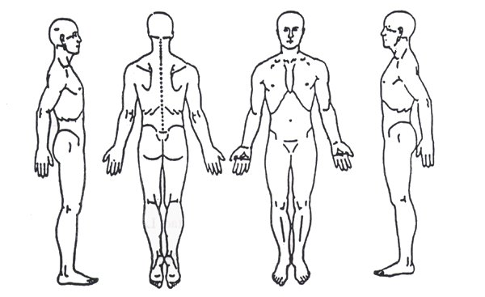

Is there anything else you feel we should know? ____________________________________________________________________
____________________________________________________________________________________________________________________________

SIGNATURE
I certify that the above information is correct to the best of my knowledge. I will not hold any therapist of any members of his/her staff responsible for any errors or omissions I may have made in the completion of this form.

Patient Name (printed): _______________________________________________

Patient Signature: _______________________________________________________ Date: ______________________________

